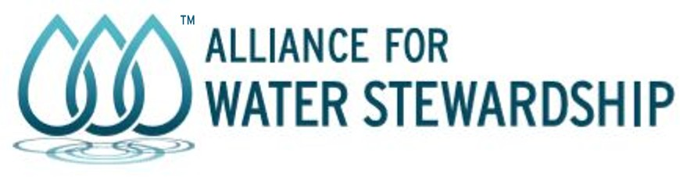

PUBLIC STAKEHOLDER ANNOUNCEMENT

Philip Morris International (PMI Papastratos Hellas) is seeking Recertification against the AWS International Water Stewardship Standard for the following site:

Site Name: | PMI Papastratos Hellas
Site Address: | Imeros Topos, Kororemi Location, Aspropyrgos, Attica 19300, Greece
GPS Site Coordinates: | 38° 6'55.62"N 23°33'43.67"E
Site Country: | Greece
AWS Site Registration  No.: | AWS-000190
Certification Body: | Water Stewardship Assurance Services (WSAS)
Start Audit Date: | 07/07/2026
End Audit Date: | 09/07/2026
Audit Format: | On-site
Audit Level: | Core
Audit Scope: | Single Site
Audit Type: | Recertification Audit

In line with the AWS Certification Requirements, the stakeholders are invited to provide their comments on the site undergoing an AWS Assessment.

Members of the public may submit comments before the audit and during the whole duration of the AWS certificate, if granted. Alternatively, an interview can be arranged with a member of the audit team. To submit comments and/or arrange an interview please email assurance@a4ws.org .
The general public and stakeholders may also contact the Alliance for Water Stewardship (AWS) with comments and questions in accordance with the AWS Comments, Complaints and Appeals Procedures (https://a4ws.org/about/comments-complaints-and-appeals).

Alliance for Water Stewardship (AWS) is registered as a Scottish Charitable Incorporated Organisation (SCO45894). Alliance for Water Stewardship, AWS and the water droplets logo are the trademarks of Alliance for Water Stewardship AWS, 2 Quality Street, North Berwick, Scotland, EH39 4HW | Website: www.a4ws.org Email: info@a4ws.org
AWS_R02_Stakeholder Announcement V3.0 (June 2024) Page 1

